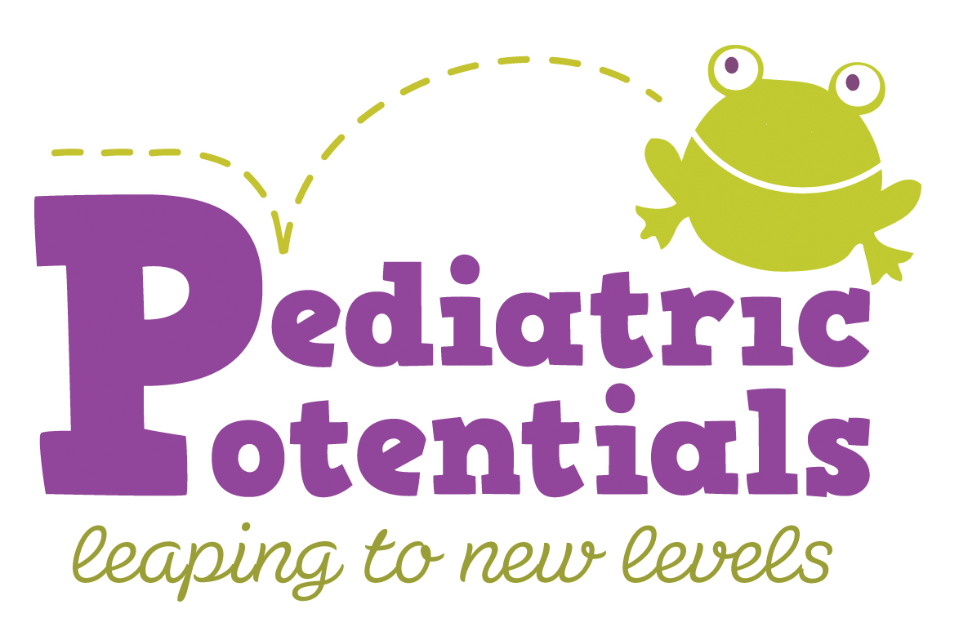

154 S. Livingston Avenue ∙ Suite 204 ∙ Livingston ∙ NJ 07039 ∙ (973) 535-5010 ∙ www.pediatricpotentialsnj.com

Directions
From the North and East:
Livingston is accessible from the Garden State Parkway, Route 280, Eagle Rock Avenue, Mount Pleasant Avenue, Northfield Road and/or South Orange Avenue.
From Route 280:
Exit at 5A – Livingston Avenue heading South. Continue on Livingston Avenue which becomes South Livingston Avenue. Cross over Mount Pleasant Avenue (large intersection with a traffic light and Starbucks Coffee on corner.) Stay straight on South Livingston Avenue for approximately 1 mile, passing the firehouse and Livingston Cleaners on the right. Just past the cleaners (large green awnings) is Enterprise Rent A Car. We are the next driveway on your right in Windsor Plaza.
Windsor Plaza is two Tudor style buildings that face each other, #154 and #160 South Livingston Avenue. (If you pass CVS Pharmacy, you’ve gone too far.) Park in back. We are located on the second floor in the building on your left when approaching from the parking lot. Suite #204.
From the South:
Take JFK Parkway North. Continue across South Orange Avenue and JFK Parkway becomes South Livingston Avenue. Cross Northfield Road and continue past Livingston High School complex (on your left). At the corner of East Cedar is a traffic light (Bee Bee Designs and CVS Pharmacy at intersection).
Our building is located approximately 50 yards ahead of that intersection on your left in Windsor Plaza complex. Windsor Plaza is two Tudor style buildings which face each other, #154 and #160 South Livingston Avenue. Park in back. We are located on the second floor in the building on your left when approaching from the parking lot. Suite #204.

Prepared by SN Pediatric Potentials, Inc. 1/2013

