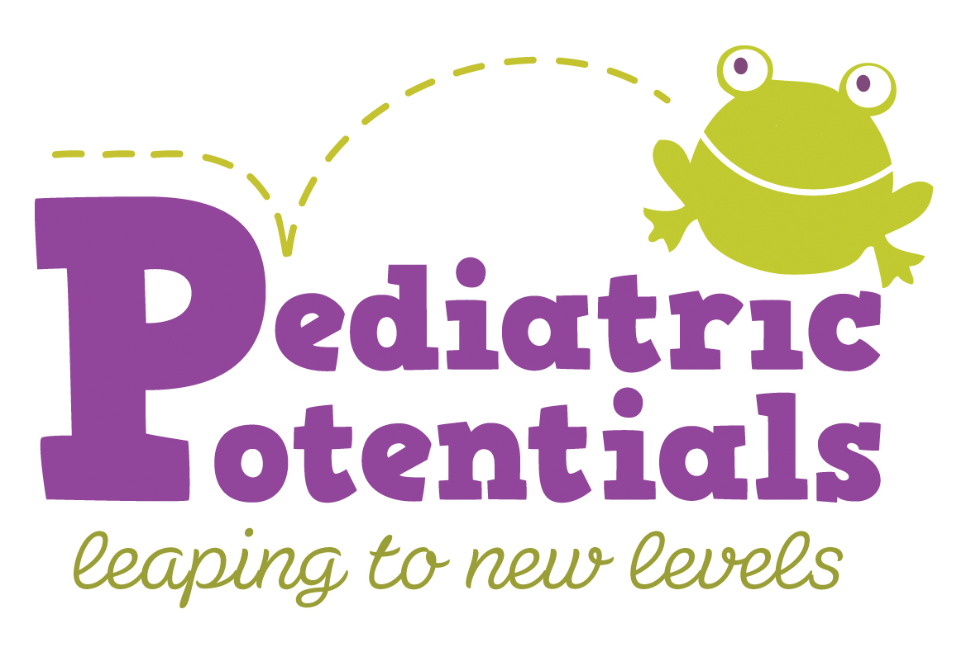

154 S. Livingston Avenue ∙ Suite 204 ∙ Livingston ∙ NJ 07039 ∙ (973) 535-5010 ∙ www.pediatricpotentialsnj.com

Release
Date: _______________

I, ______________________________ hereby give permission for _______________________
(Parent/Guardian name) (Therapist name)
to release information regarding my son/daughter __________________________, from
(Child’s name)

______________________________________________________________________________
(Name of Facility and Address)

____________________________________________
(Signature of Parent/Guardian)

Permission is specifically granted to release information to:
(Please list treating therapists, teachers, physicians, etc.)

Name: ___________________________ Address: _____________________________________

Title: _______________________ Phone #: __________________ Cell: __________________

Name: ___________________________ Address: _____________________________________

Title: _______________________ Phone #: __________________ Cell: __________________

Name: ___________________________ Address: _____________________________________

Title: _______________________ Phone #: __________________ Cell: __________________

Release of information with the following is NOT permitted.

__________________________________________________________________________________________

__________________________________________________________________________________________

I do not give permission to release any information regarding my child.

_________________________ _________________________________________
Child’s name Signature of Parent/Guardian

Prepared by SN Pediatric Potentials, Inc. 1/2013

